**Northern Region (NR) – Regional Functional Committee (2025-2027)**

**Ms. Pooja Sehrawat, President, WIPS -NR**

|  |  |
| --- | --- |
| Photo | write up |
|  | **Ms. Pooja Sehrawat is working for POWERGRID as chief Manager (Library).She is Post Graduate in Political Science (Hindu college, Delhi university) and has Master in Library and Information science from Delhi University.**  **She has been a member of WIPS since 2016 and became an Executive Committee Member in 2019, contributing significantly during both Regional and National Meetings. She served as the Secretary of WIPS NR from 2021 to 2023 and is currently the President of WIPS-NR. Her involvement has been crucial in furthering the organization and WIPS objectives.**  **In addition to her role in WIPS, she has been a member convener of the Sexual Harassment Committee at POWERGRID for two terms, from 2017 to 2020 and from 2023 to 2026. Her contributions to women's empowerment were recognized in 2018 when she received an award from the Parivartan Jan Kalyan Samiti Society, an NGO based in Delhi. Outside of her professional commitments, she enjoys reading, music, and travel, and actively volunteers with various NGOs, including the Art of Living and ISCON.** |

**Ms. Shilpa Mayenkar, Vice-President, WIPS -NR**

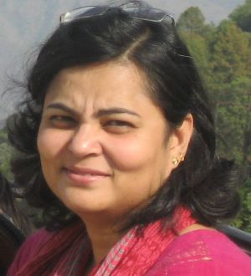

**Ms. Mayenkar is working as Addl. General Manager(HR) in Corporate Office of BHEL.  She holds a graduate degree in Psychology & a post -graduate degree in Social Work from University of Delhi. Joined BHEL as Executive Trainee (HR) In 1998, she is responsible for HR Policy formulation and implementation at company level.  She is also a certified SAP-HCM Functional Consultant. She has been actively associated with WIPS for more than a decade as EC member of WIPS, NR and is the company Co- ordinator of WIPS for BHEL.**

Ms. Akansha Wadhwa, Treasurer**, WIPS -NR**

Ms. Akansha Wadhwa, is a Chartered Accountant by profession and has served in the Finance and Accounts Department of NLC India Limited. Beyond her core responsibilities, she has successfully undertaken several key assignments, including pilot projects aimed at reducing air travel, medical, and hotel expenditures across all CPSEs under various Ministries and Government Departments.

Initially serving as REB from NR and later as **Treasurer of WIPS-NR,** she has consistently played a pivotal role in advancing the objectives of WIPS. Her contributions have been recognized with the NLCIL Excel Employee Award in 2022 and the Best Performer Award – Women Executive for 2021–23, in acknowledgment of her outstanding performance.

Ms. Pragati Sharma ,**Secretary of WIPS-NR**

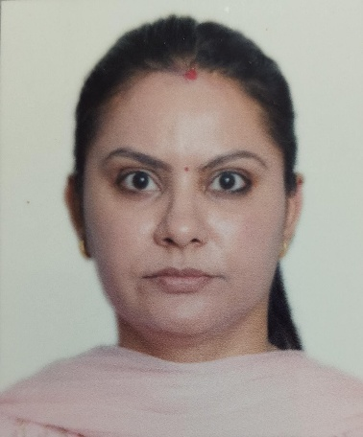

Ms. Pragati Sharma currently serves as Deputy General Manager (Business Head) at the Central Warehousing Corporation (CWC), Regional Office, Delhi. With a distinguished career spanning multiple key divisions—including ICD PPG, Vigilance, Commercial, and Human Resources—at CWC’s Corporate Office, she has demonstrated exceptional leadership and strategic acumen.

Notably, Ms. Sharma broke new ground by becoming the **first female manager of ICD PPG**, India’s pioneering dry port, setting a precedent for women in logistics and infrastructure management.

Her commitment to empowering women in public sector enterprises is equally commendable. Beginning as REB from the Northern Region (NR), she later took on the role of **Secretary of WIPS-NR (Women in Public Sector – Northern Region)**, where she has been instrumental in driving initiatives that promote gender equity and professional development for women across the sector.

Ms. Sharma’s career reflects a blend of operational excellence, visionary leadership, and unwavering dedication to inclusive growth.

MG